

23CSIS10P

Introduction to Information Systems

Phase 2 Report

Hotel data base

Project Description:
We want to create a database to store data about a hotel. For each guest, it’s important to know his social security number, name, date of birth, phone number, gender, email, room type, room code, payment number along with his check-in and check-out dates. These information is gathered by the receptionist. Each receptionist has a unique ID, a name, date of birth, salary, gender and building ID. The reservation made by the guest has a unique number, a booking date, arrival date, departure date, room type and price, guest ID, guest’s email, guest’s phone number and guest’s social security number. Each room in the hotel has a unique code, type, price per night, location, capacity, building ID and availability. Each housekeeper of the rooms has a social security number, gender, contact information, salary and number of working hours. The hotel consists of many buildings, there is a unique building ID, location, number of floors, type and manager for each building. The hotel also has many facilities. For each one, there is a unique facility type, opening and closing times, restrictions and location. Each event organized by the hotel has a unique name, type, organizer, start and end dates, building ID and hall number. Each hall has a unique number, type, availability, capacity and Building ID. Also, Maintenance staff each has a unique social security number, a name, date of birth, address, contact information, salary, renovation type and building ID. Each manager of the hotel has a unique social security number, a name, date of birth, address, job description, area of responsibility, contact information, number of experience years and building ID. Before the departure of the guest, a bill is paid. Each bill has a unique number, a method, date, amount, reservation number and the guest’s social security number.

Entity Relationship Diagram:

N
M
Facility
N
M
Maintenance
1
1
Manager
M
1
Event
M
1
M
1
Hall
Receptionist
1
M
N
M
Housekeeper
Building
Room
M
1
M
1
Reservation
1
1
Bill
Guest

Tables and Attributes:

Bill
Bill_Number(PK) | Number
Bill_Method | Short Text
Bill_Date | Date/Time
Bill_Amount | Currency
Guest_SSN(FK) | Number
Reservation_Number(FK) | Number

Building
Building_ID(PK) | Number
Building_Name | Short Text
Building_Number_Of_Floors | Number
Building_Type | Short Text
Building_Manager_Code | Short Text
Building_Facility | Short Text
Manager_SSN(FK) | Number

Cleans
Room_Code(PK) | Number
Housekeeper_SSN(PK) | Number
Cleaning_Day | Date/Time

Event
Event_Number(PK) | Number
Event_Type | Short Text
Event_Organizor | Short Text
Event_Begining_Date | Date/Time
Event_End_Date | Date/Time
Event_Building_ID(FK) | Number
Hall_Number(FK) | Number

Facility
Facility_Code(PK) | Short Text
Facility_Open_Time | Short Text
Facility_Close_Time | Short Text
Facility_Location | Short Text
Facility_Type | Short Text

Fixing
Maintenance_ID(PK) | Number
Facility_Code(PK) | Short Text
Maintenance_Time | Date/Time
Facility_Location | Short Text

Guest
Guest_SSN(PK) | Number
Guest_Full_Name | Short Text
Guest_Room_Number | Number
Guest_DOB | Date/Time
Guest_Phone_Number | Number
Guest_Checkin_Date | Date/Time
Guest_Checkout_Date | Date/Time
Guest_Gender | Short Text
Guest_Email | Short Text

Hall
Hall_Number(PK) | Number
Hall_Type | Short Text
Hall_Availability | Yes/No
Hall_Capacity | Number
Building_ID(FK) | Number

Housekeeper
Housekeeper_SSN(PK) | Number
Housekeeper_Gender | Short Text
Housekeeper_Contact_Info | Number
Housekeeper_Salary | Currency
Housekeeper_Working_Hours | Number
City | Short Text

MaintenanceOfBuildings
Maintenance_ID(PK) | Number
Building_ID(PK) | Number
Issue | Short Text

Maintenance
Maintenance_ID(PK) | Number
Maintenance_Start_Date | Date/Time
Maintenance_End_Date | Date/Time
Maintenance_Renovation_Type | Short Text
Maintenance_Building_ID(FK) | Number
Maintenance_Status | Short Text
Last_Maintenance | Date/Time

Manager
Manager_SSN(PK) | Number
Manager_Name | Short Text
Manager_DOB | Date/Time
Manager_Address | Short Text
Job_Description | Short Text
Manager_Years_Of_Experience | Number
Manager_Mail | Long Text
Manager_Building_Code | Short Text

Receptionist
Rec_ID(PK) | Number
Rec_First_Name | Short Text
Rec_Mid_Name | Short Text
Rec_Last_Name | Short Text
Rec_DOB | Date/Time
Rec_Salary | Currency
Rec_Gender | Short Text
Rec_Building_ID(FK) | Number

Reservation
Res_number(PK) | Number
Res_booking_date | Date/Time
Res_arrival_date | Date/Time
Res_departure_date | Date/Time
Room_type | Short Text
Room_price | Currency
Guest_ID | Number
Guest_Email(FK) | Hyperlink
Guest_Phone_Number(FK) | Number
Guest_SSN(FK) | Number

Room
Room_Num(PK) | Number
Room_Price_per_Night | Currency
Room_Type | Short Text
Room Availability | Short Text
Room_floor | Short Text
Room_Capacity | Number
Room_Building_ID(FK) | Number
Res_number(FK) | Number

Database Schema (Clear Screenshot from Microsoft Access):

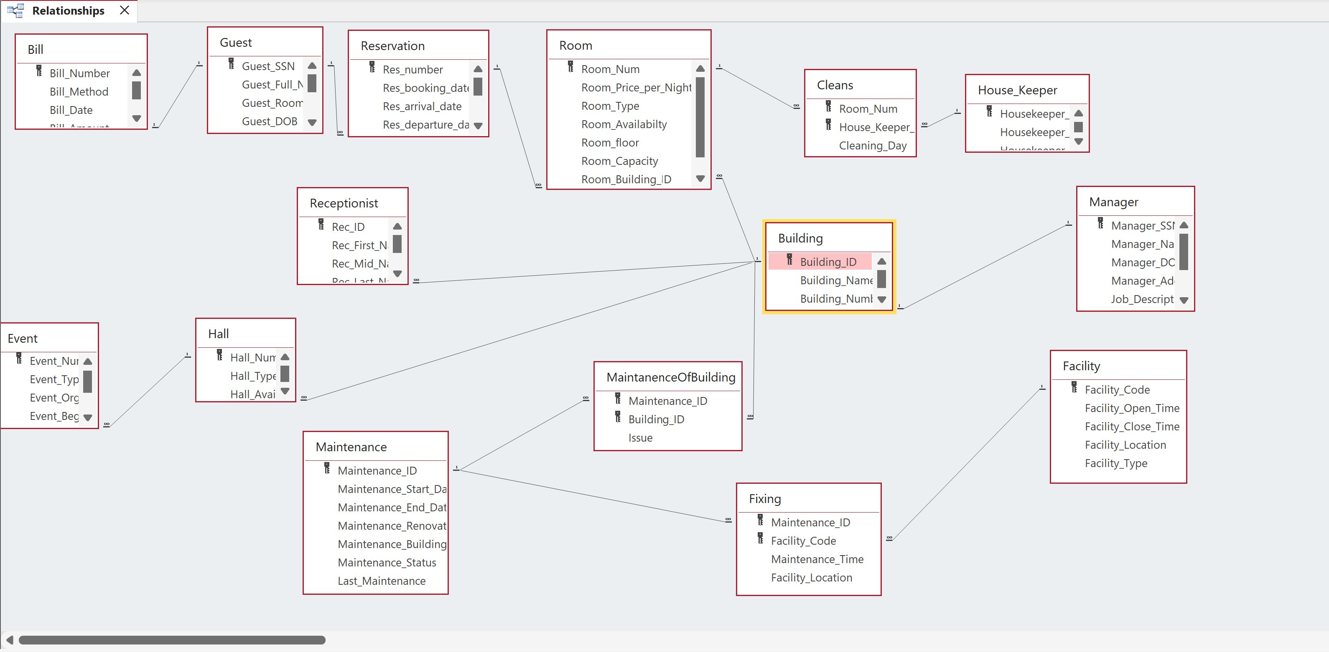

Application Form 1:
EVENT INFORMATION FORM:
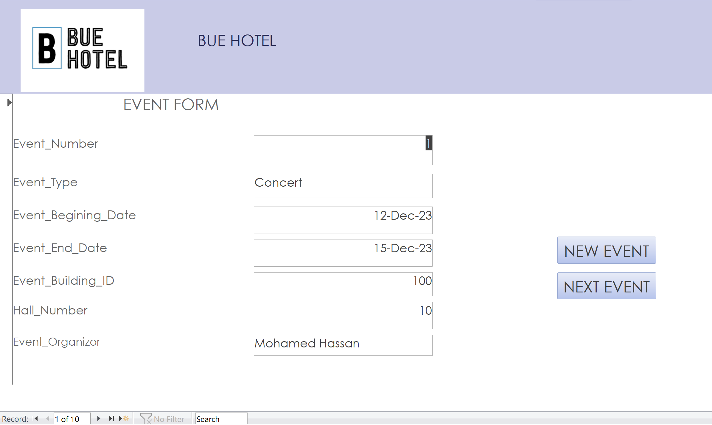

Description of Output:
This form inputs information about every new event in the event table.

Application Form 2:
MANAGER INFORMATION FORM:
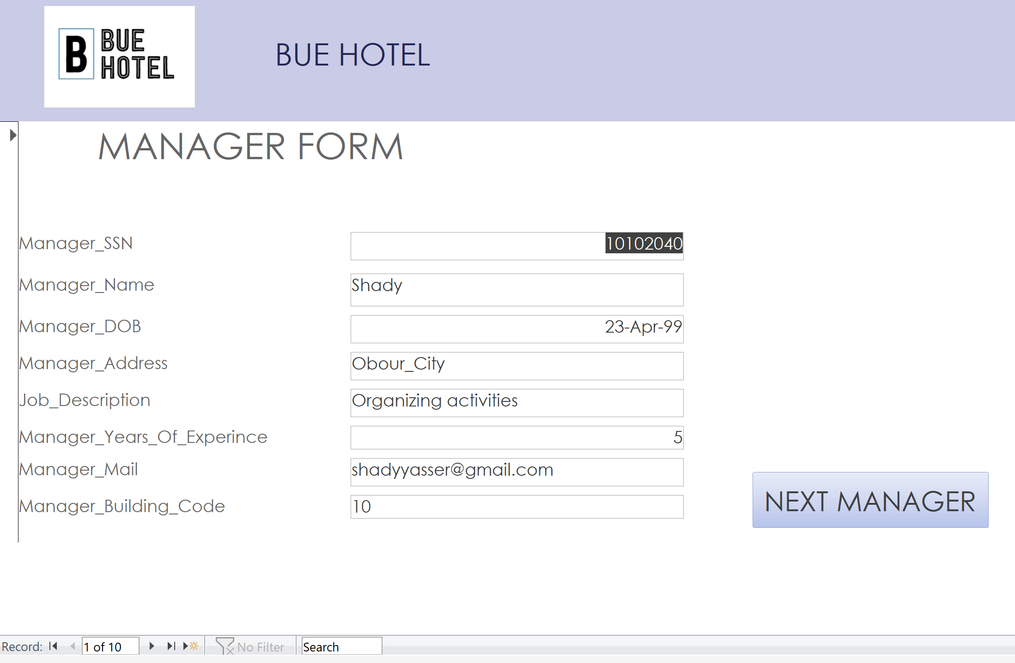

Description of Output:
This form inputs the information of each manager.

Application Form 3:
HOUSEKEEPER_DATA FORM:

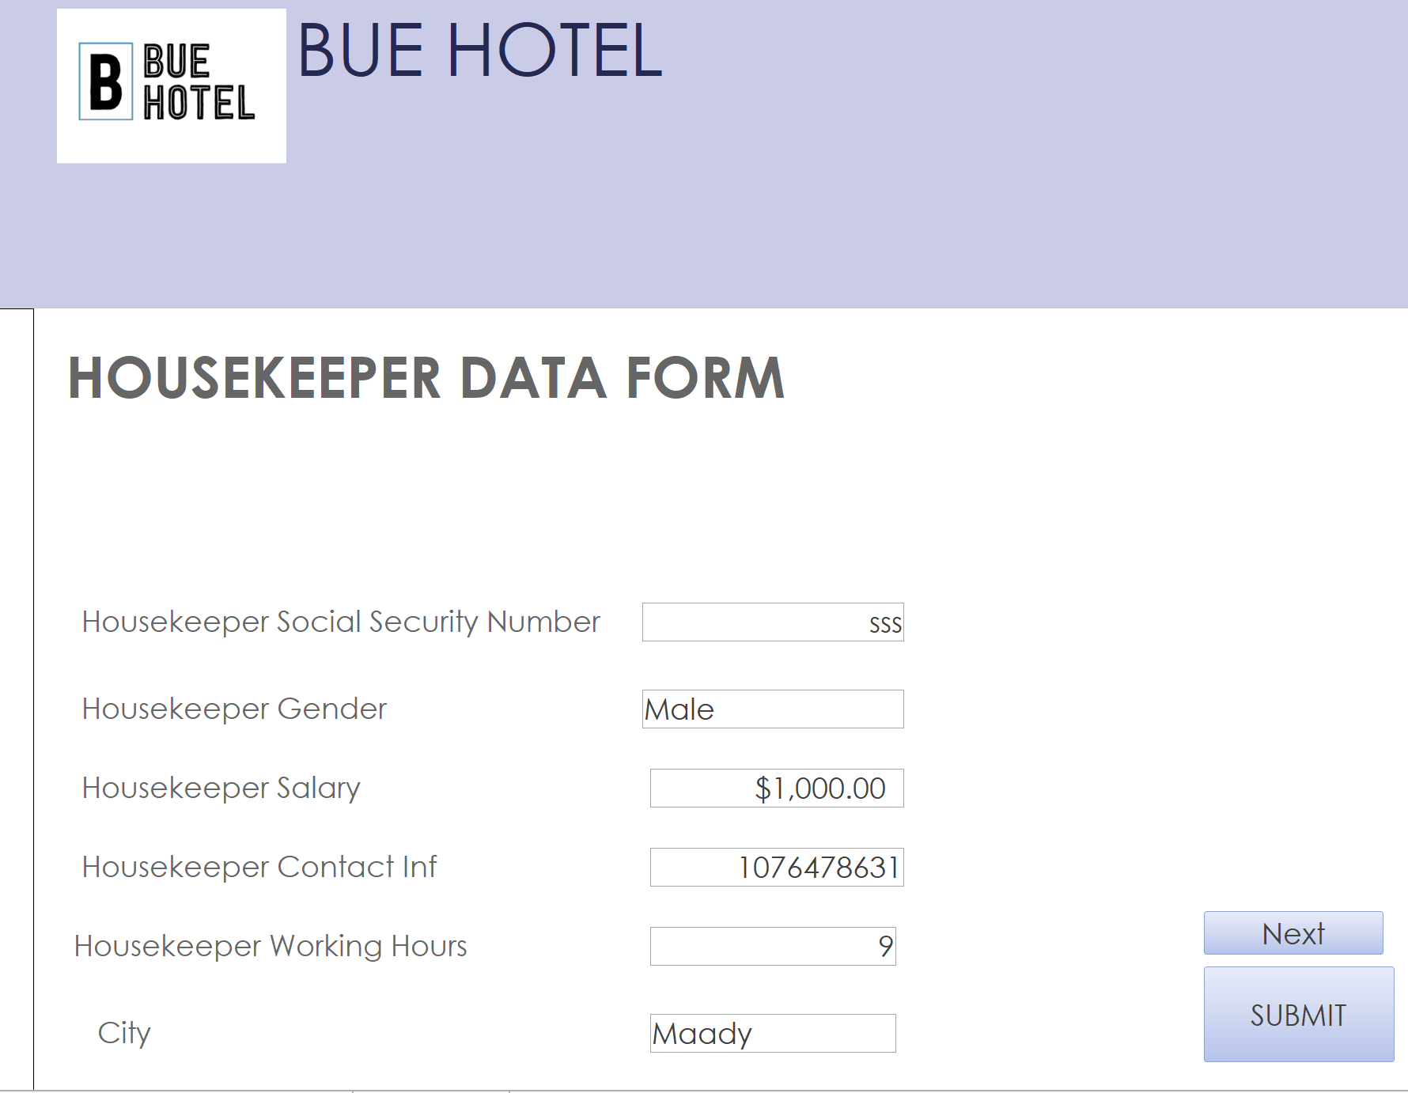

Description of Output:
A sub_form that would assign courses to the newly added housekeeper members.

Application Form 4:
Maintenance Form:
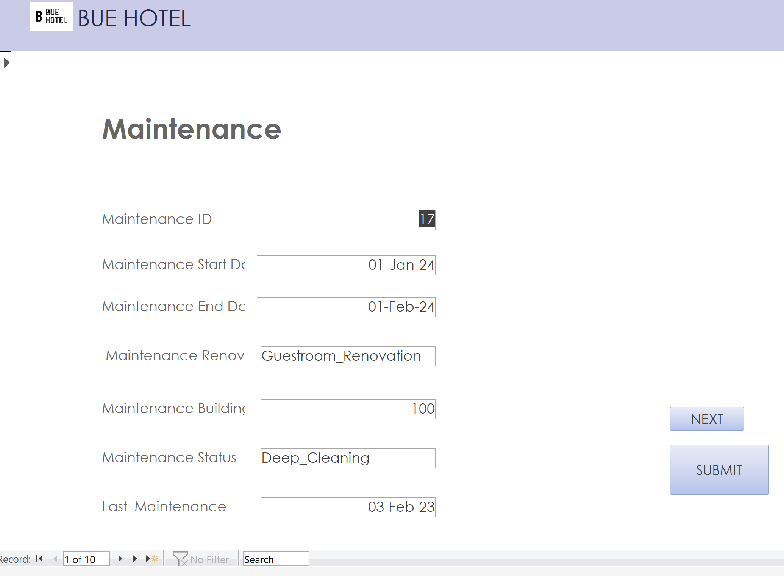

Description of Output:
A Sub_form to assign the data of maintenance.

Application Form 5:
Payment Information Form:
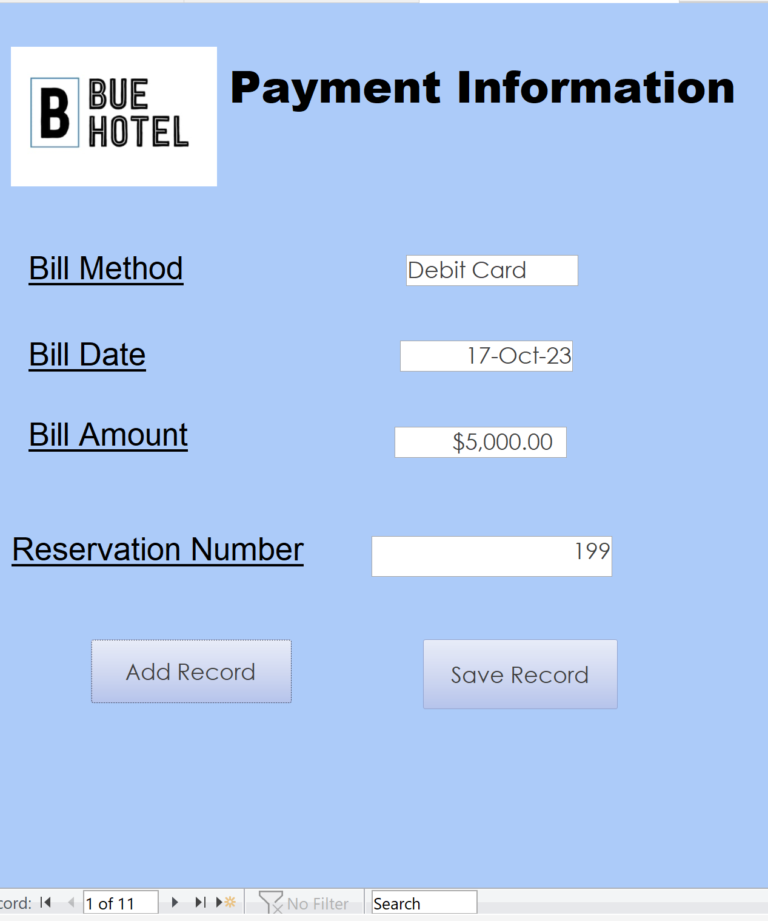

Description of Output:
This form inputs the payment information of a new guest in the Bill table.

Application Form 6:
Guest Information Form:
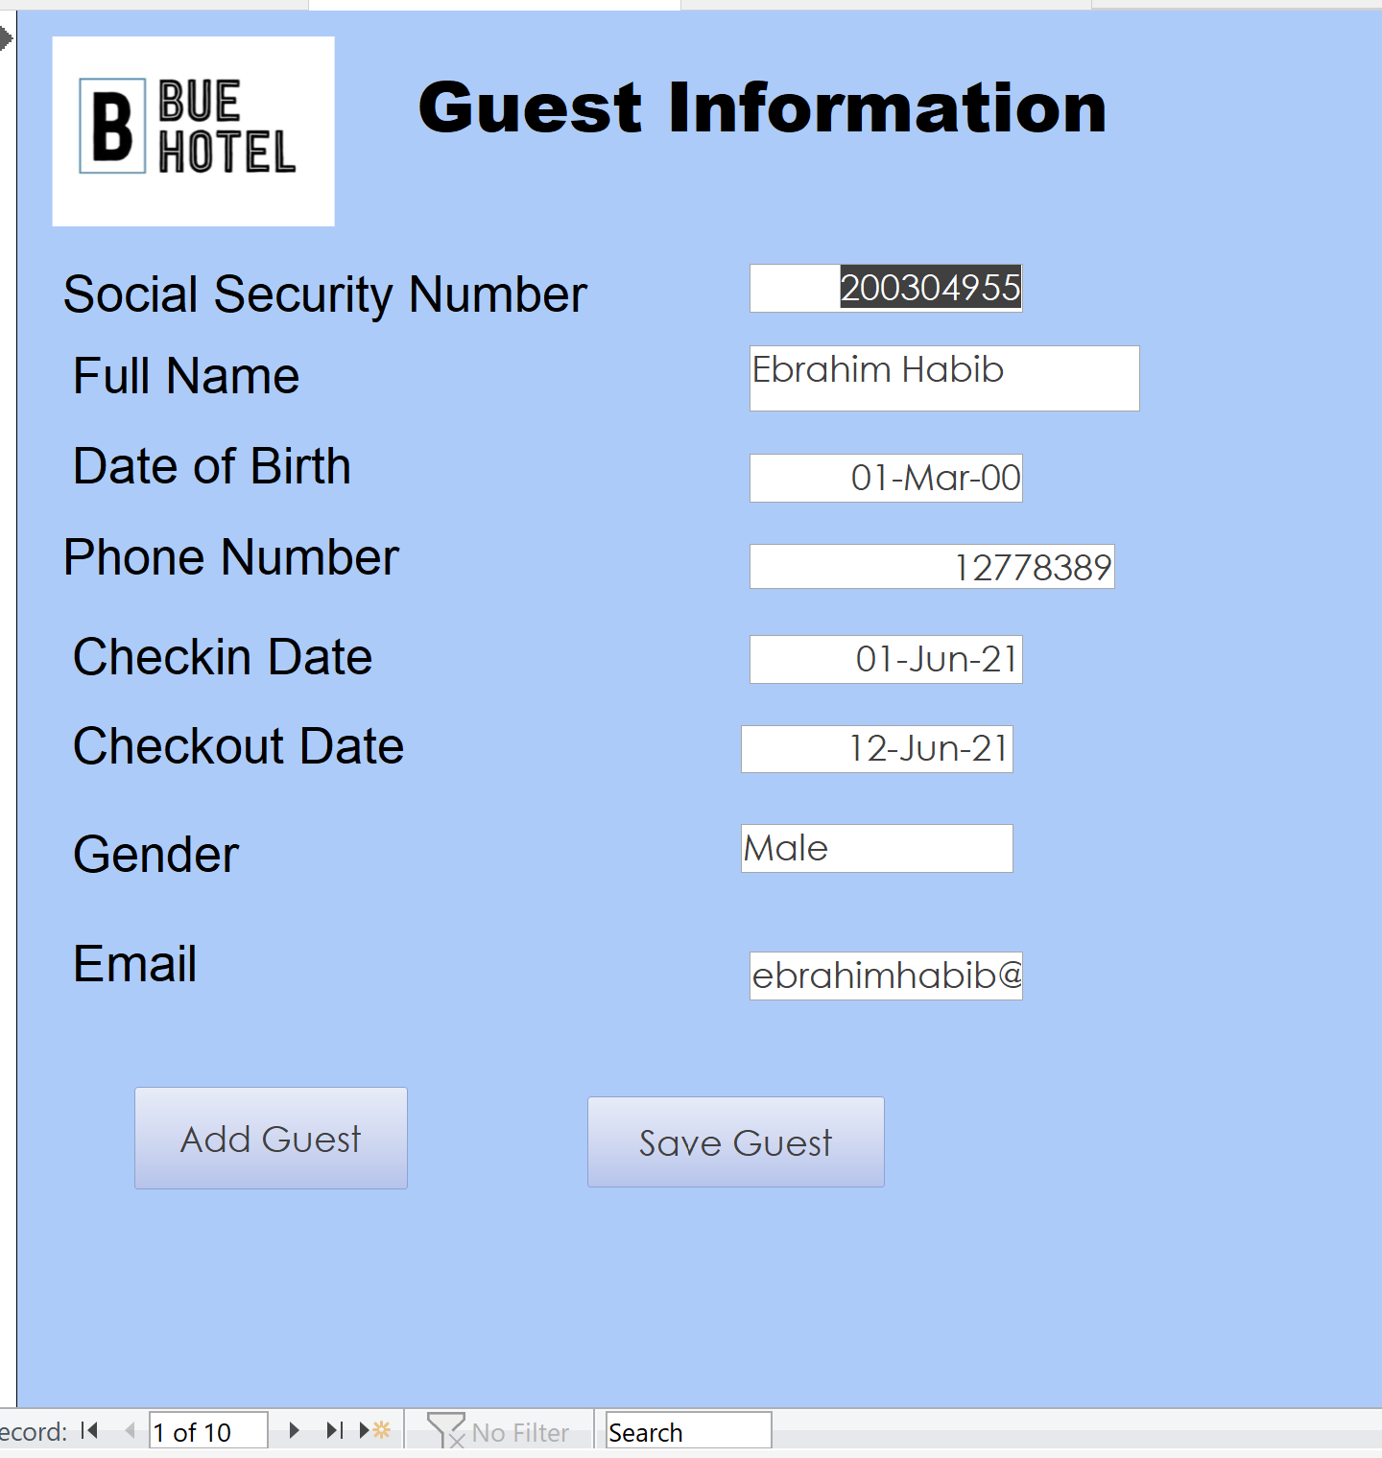

Description of Output:
This form inputs the information of a new guest in the Guest table.

Application Form 7:
Room Form:
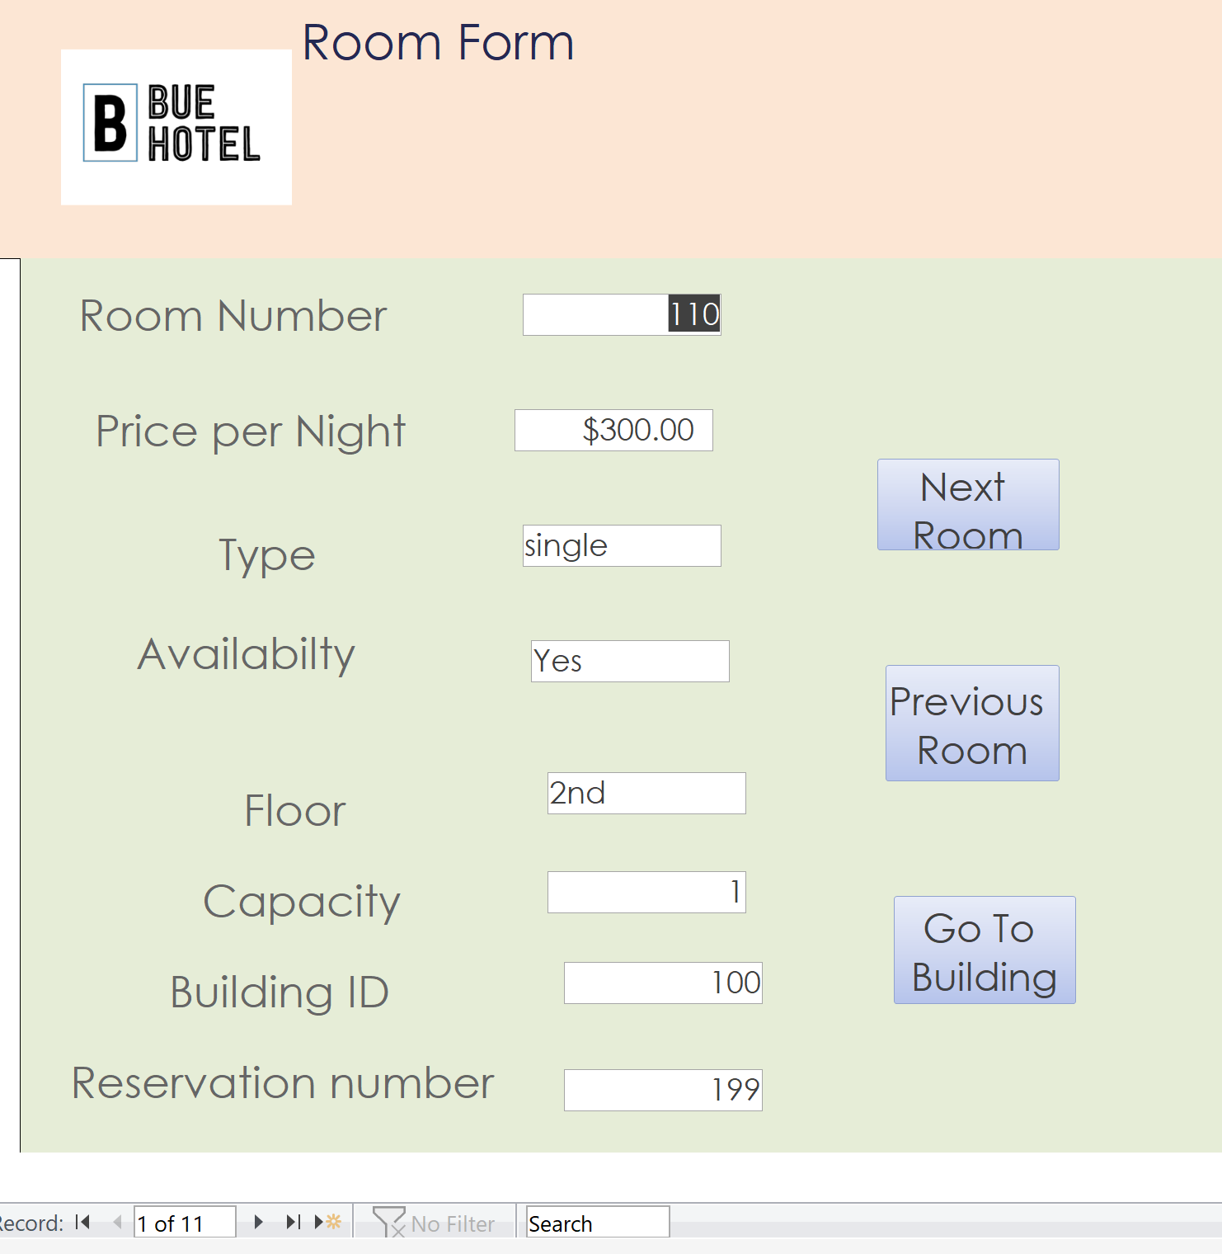

Description of Output:
The room form is to help the staff to check the rooms and to change them.

Application Form 8:
Building Form:
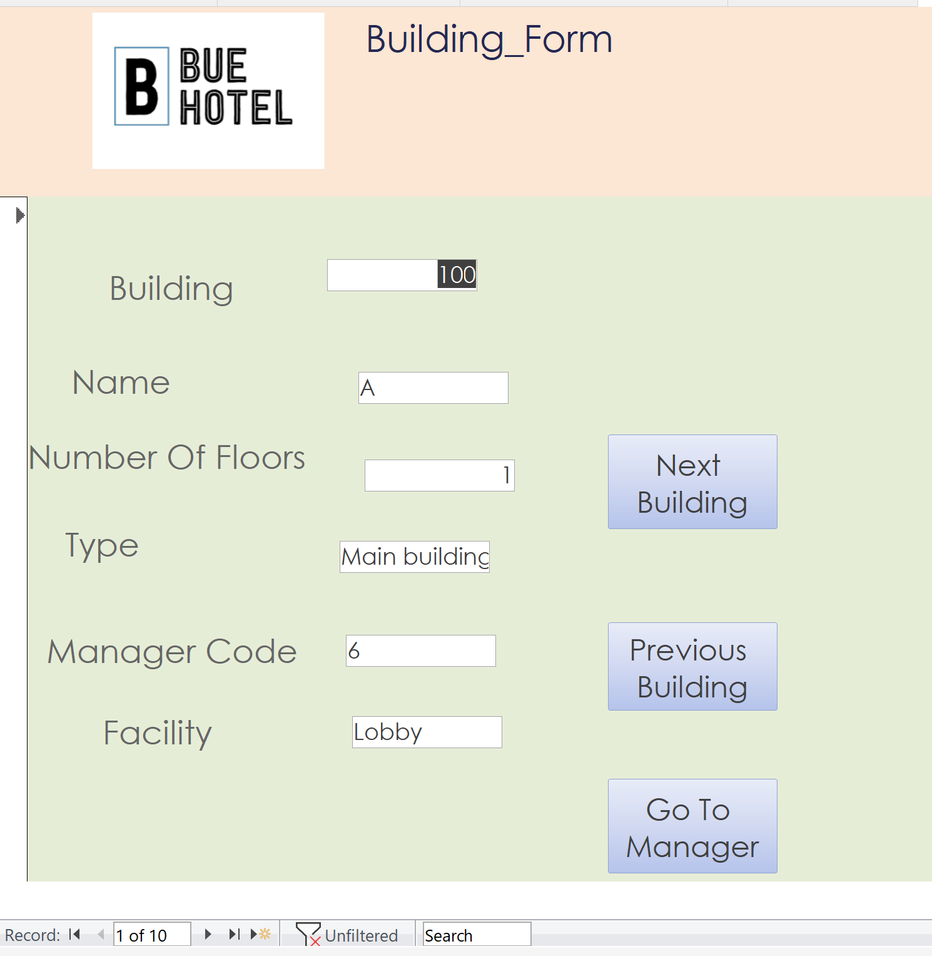

Description of Output:
The building form helps the staff to check the buildings and to check every manager responsible for that building and to change in it.

Application Form 9:
Receptionist Form:
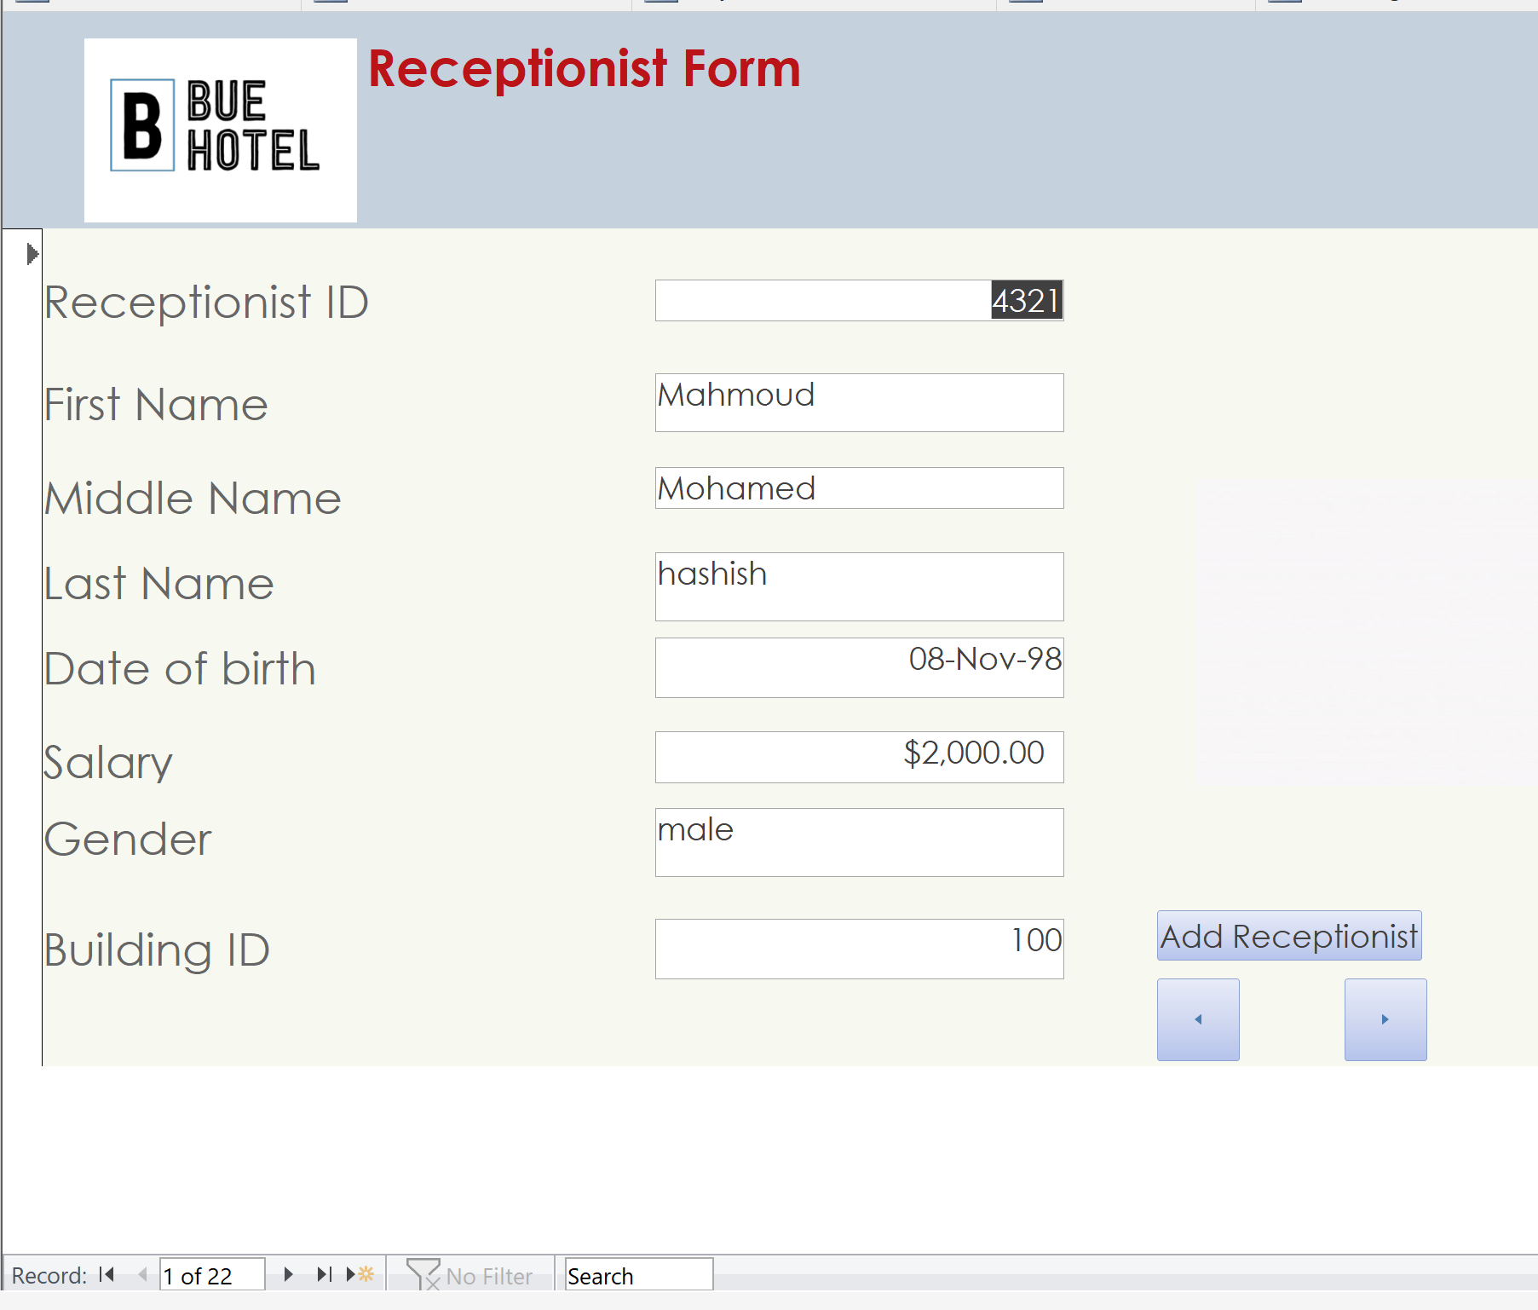

Description of Output:
This form is to add new receptionists or view data about specific receptionist.

Application Form 10:
Reservation Form:
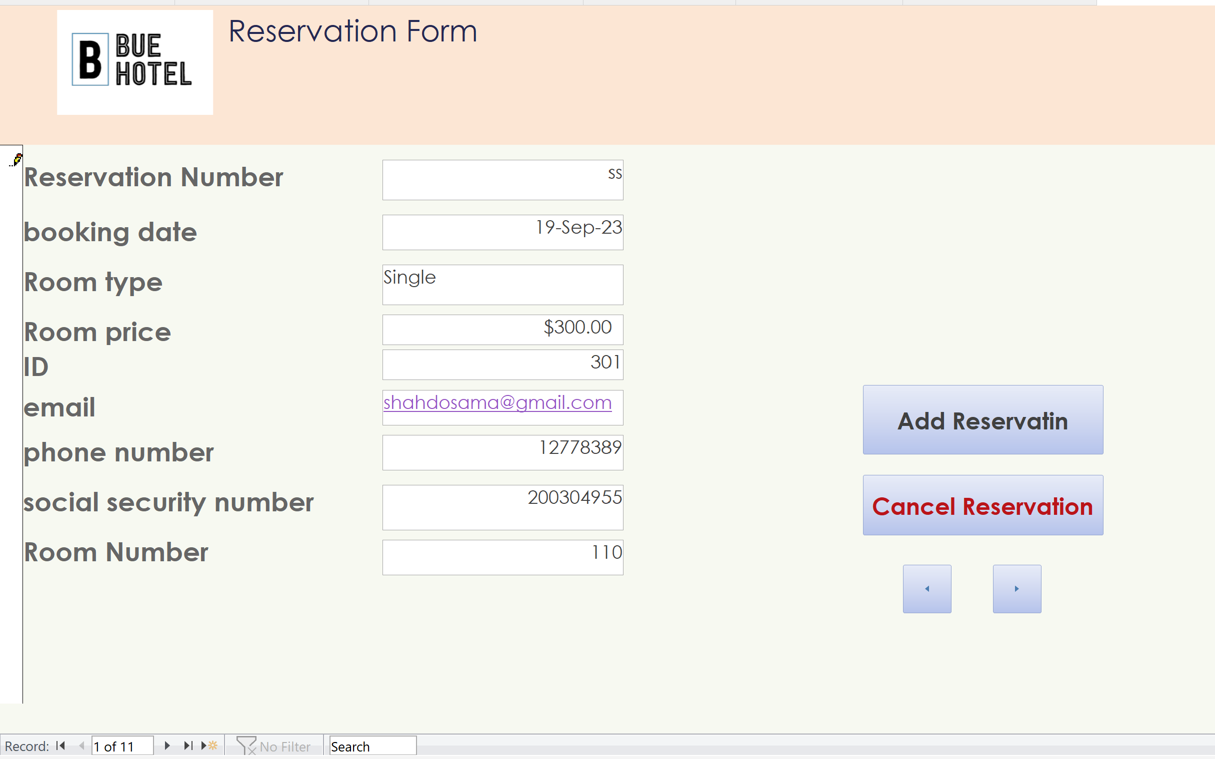

Description of Output:
This form is to add new reservation or cancel a reservation.

Application Form 11:
Hall Form:
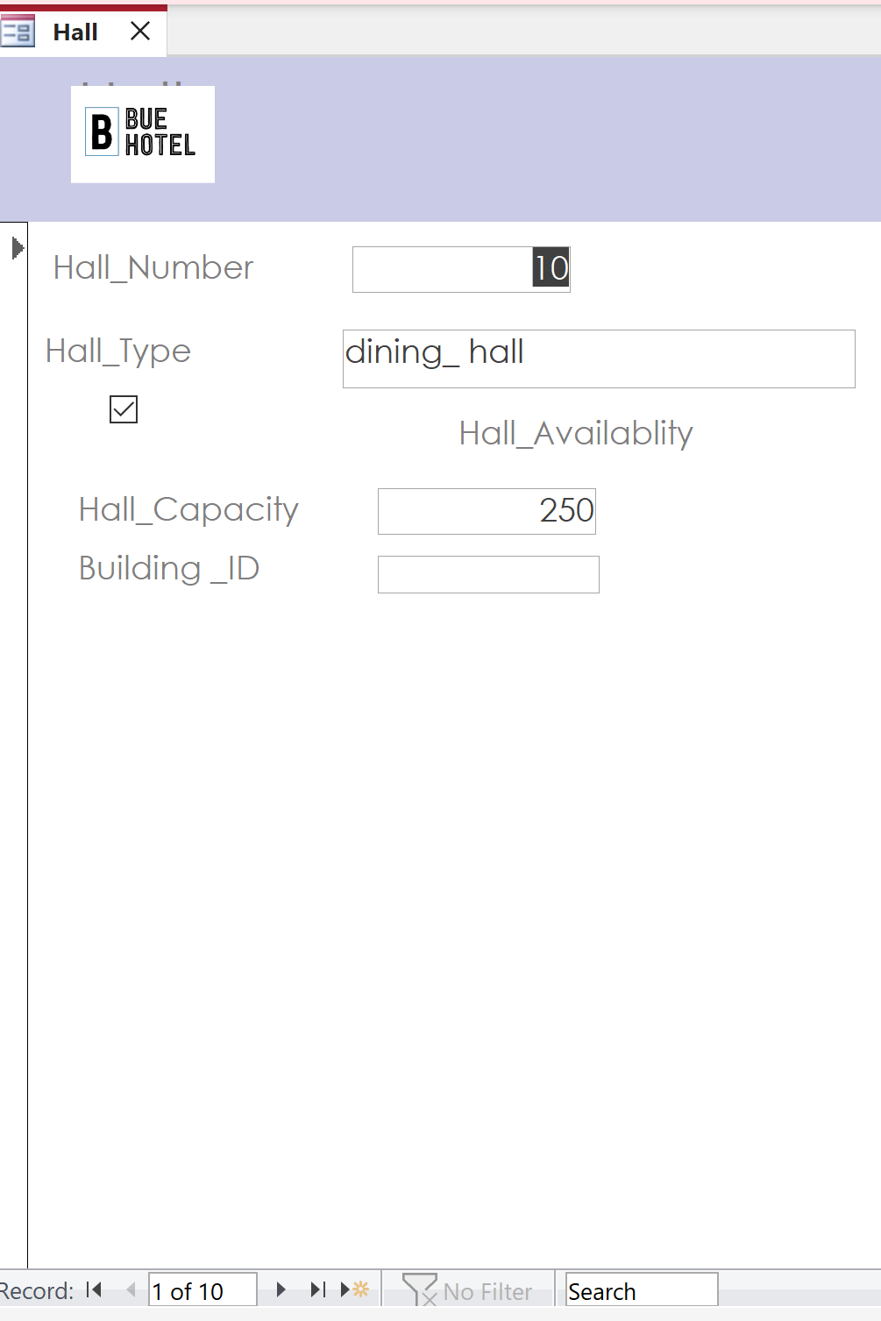

Description of Output:

Application Form 12:
Facility Form:
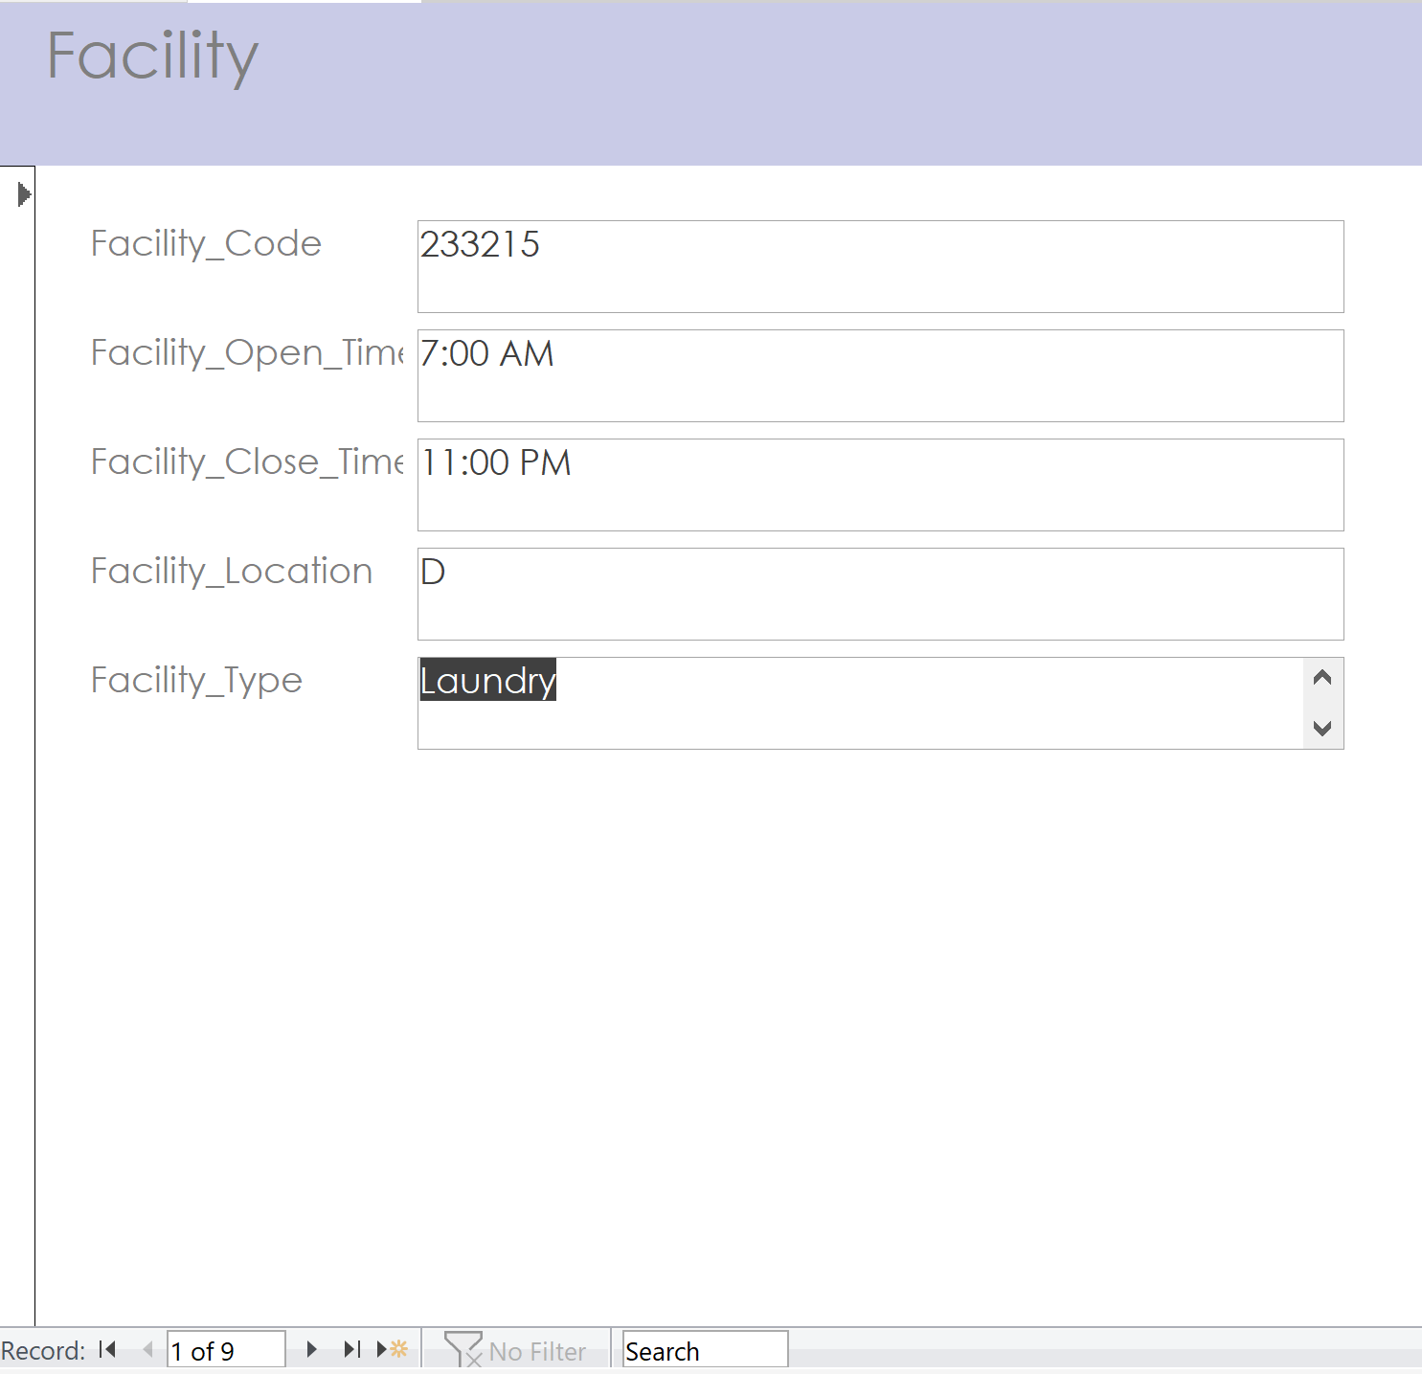

Description of Output:

Report 1:
EVENT REPORT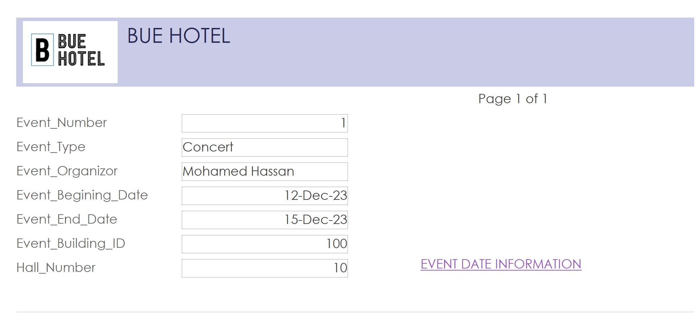

Description of Output:
This report displays all the details of each event and gives you the option to go to the event date information directly.

Report 2:
EVENT DATE INFORMATION REPORT
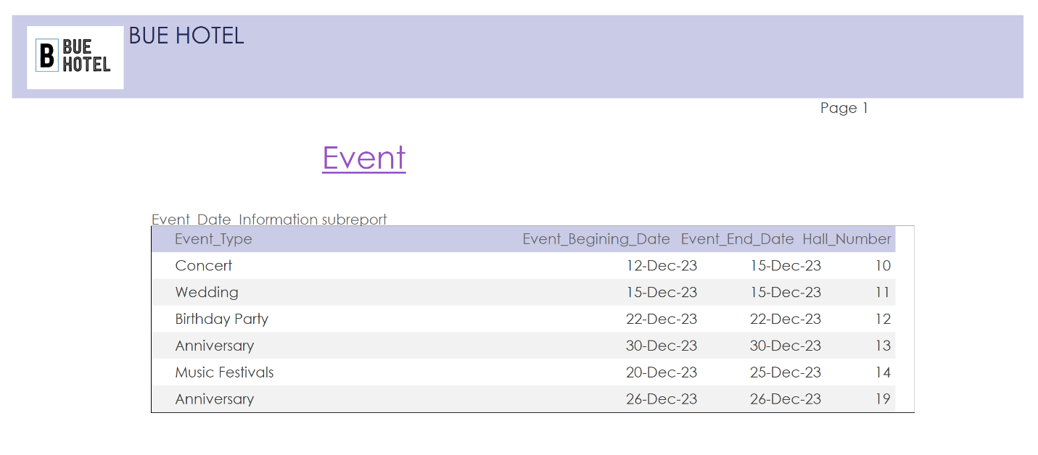

Description of Output:
This report displays the start date and end date of each event between 12/1/2023 to 12/30/2023 and their hall numbers and the event type. (from event date information query)

Report 3:
MAINTENANCE REPORT:
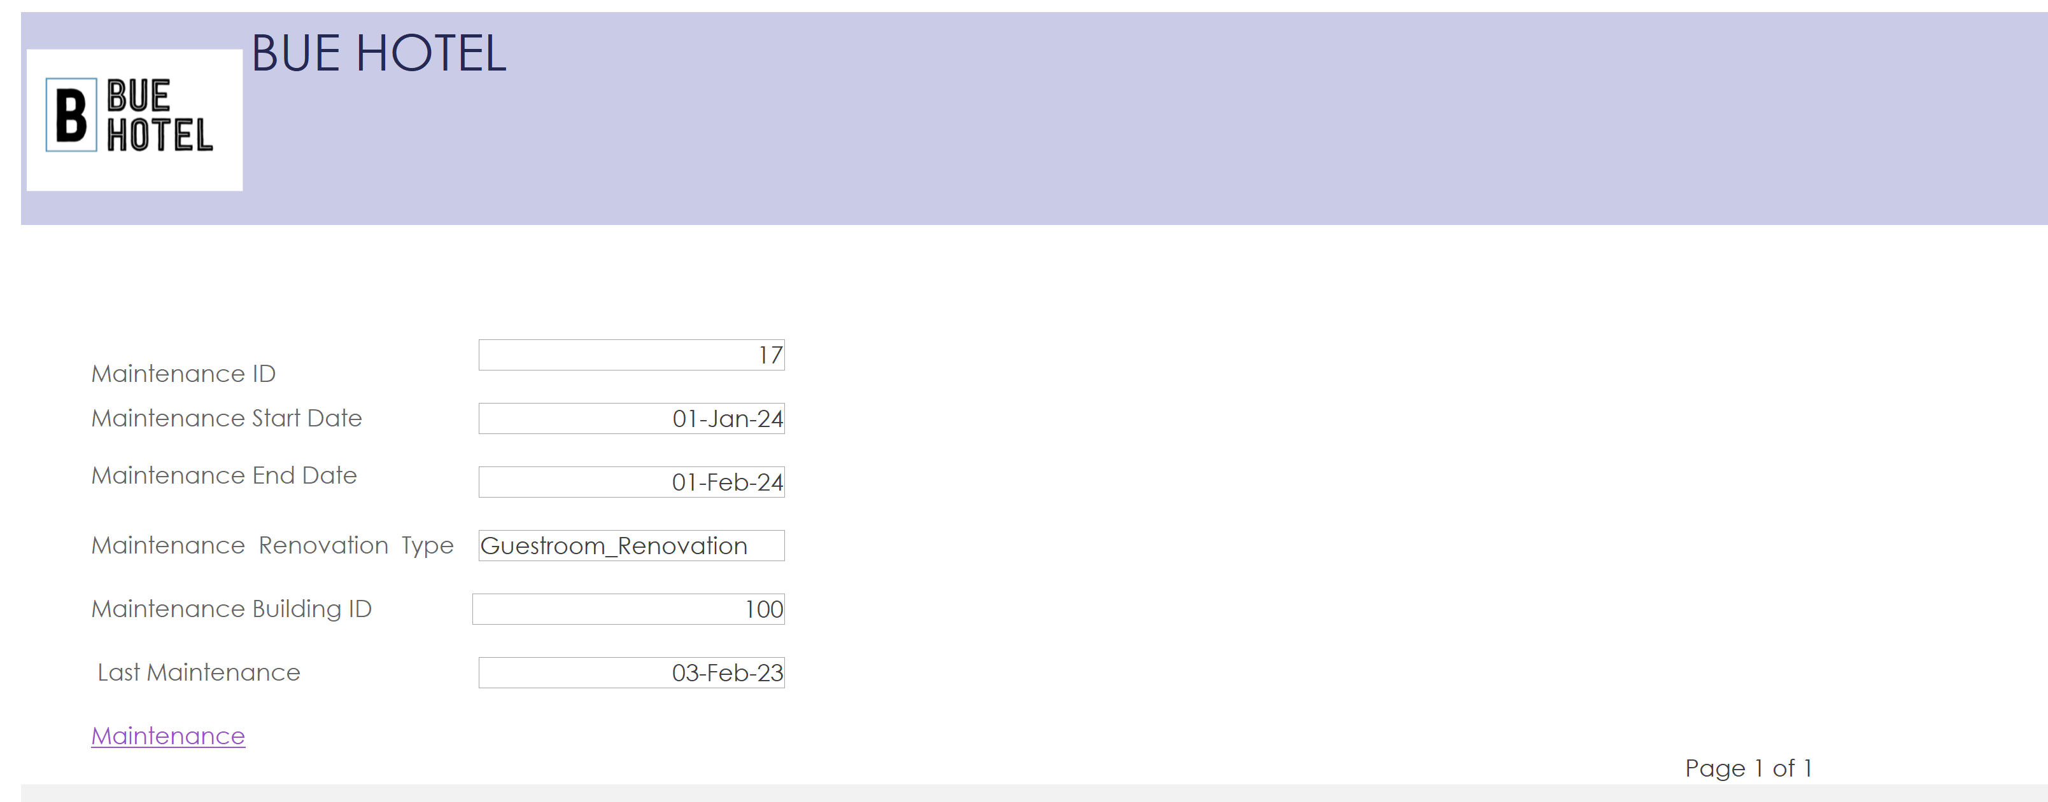

Description of Output:
A report that shows maintenance data.

Report 4:
NUMBER_OF_HOUSEKEEPER_GENDER_IN_EACH_CITY:
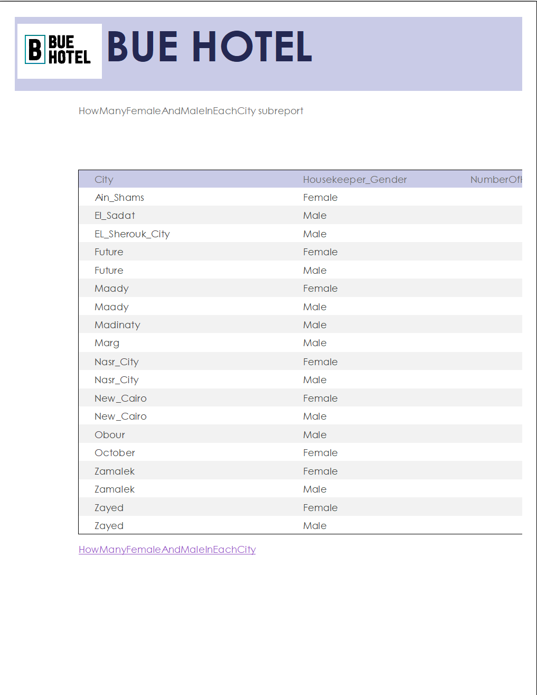

Description of Output:
A report that shows how many housekeepers female and male in each city.

Report 5:
Guests with more than $3000 bill amount:
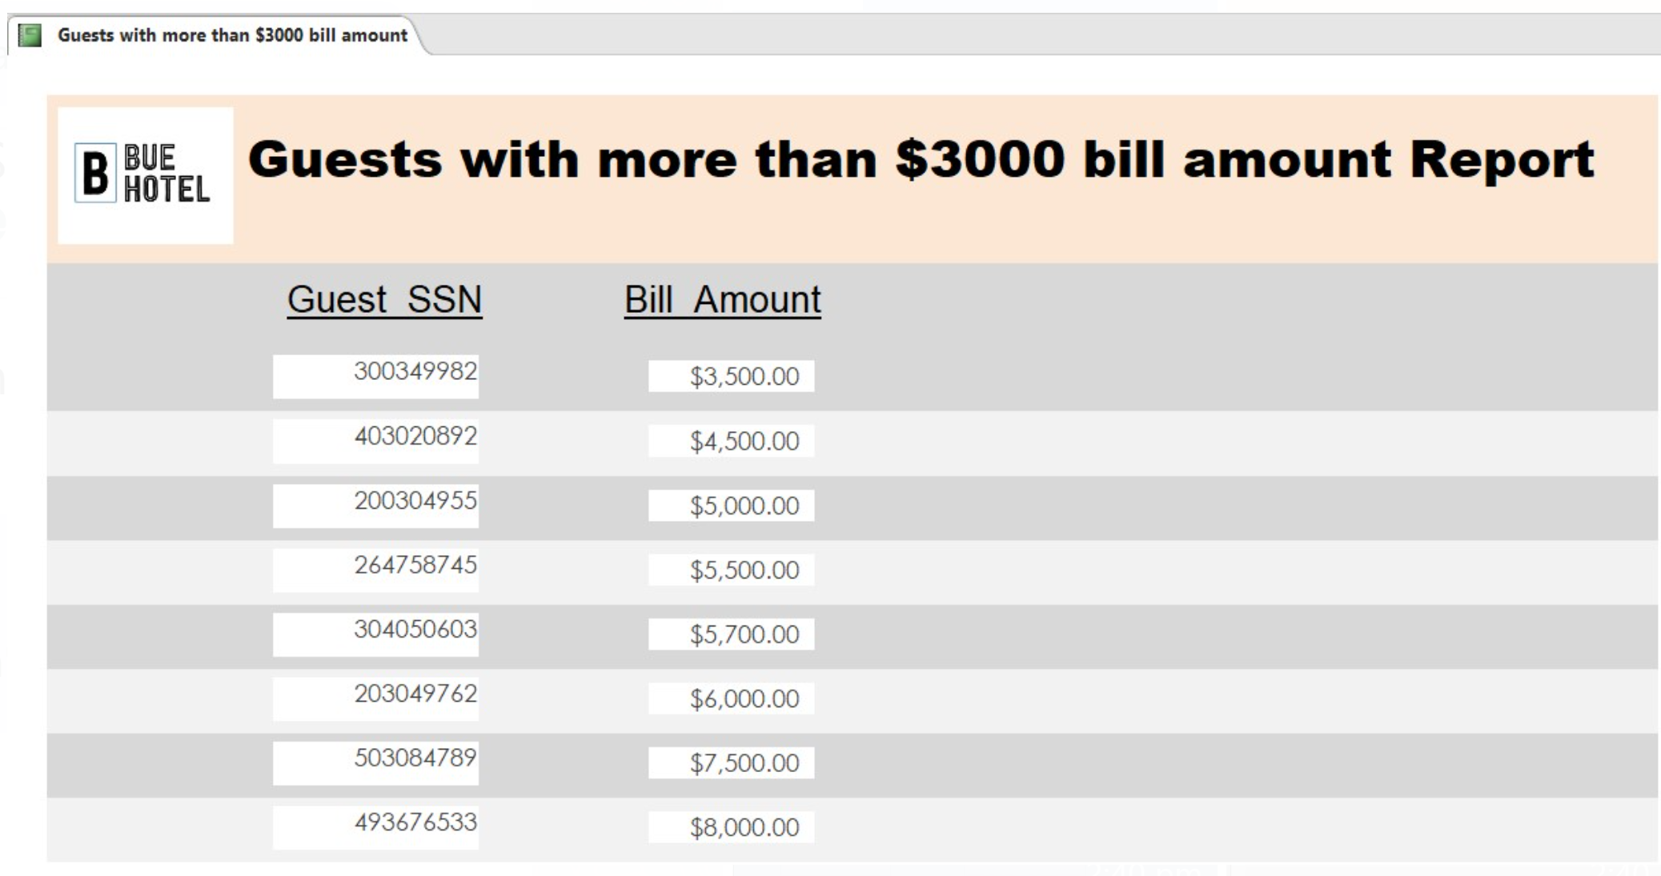

Description of Output:
This report displays the guests, identified by the SSN, with more than $3000 bill amount.

Report 6:
Bill Information Report:
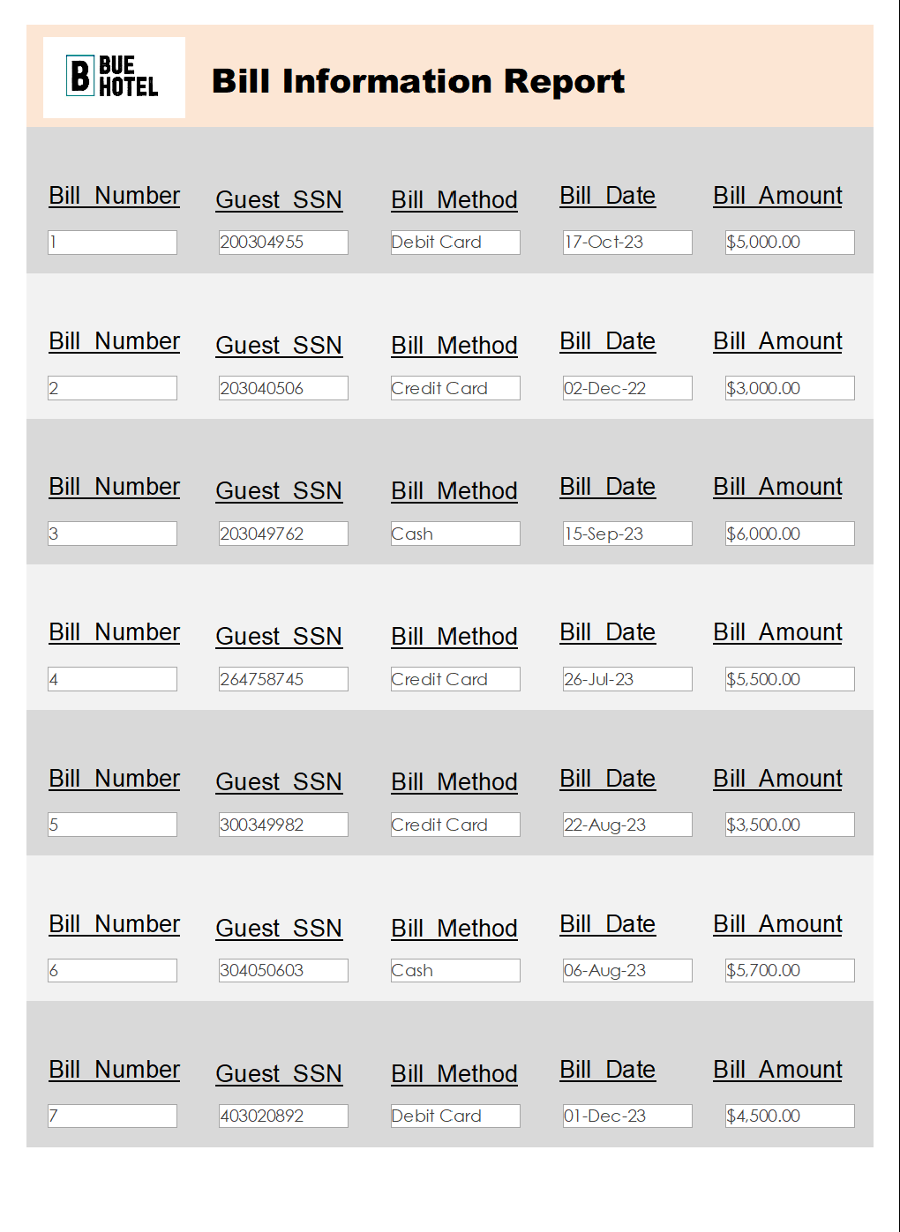

Description of Output:
This report displays the bill information of each guest.

Report 7:
Receptionists’ salaries report:
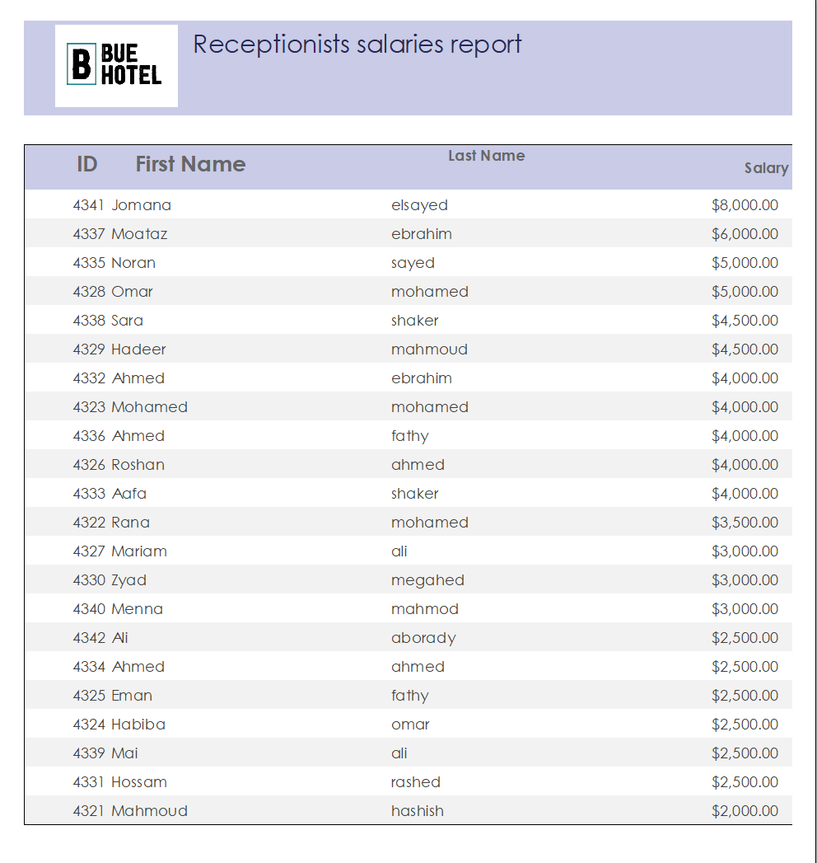

Description of Output:
This report is to show data about receptionists' salaries.

Report 8:
Reservation Report:
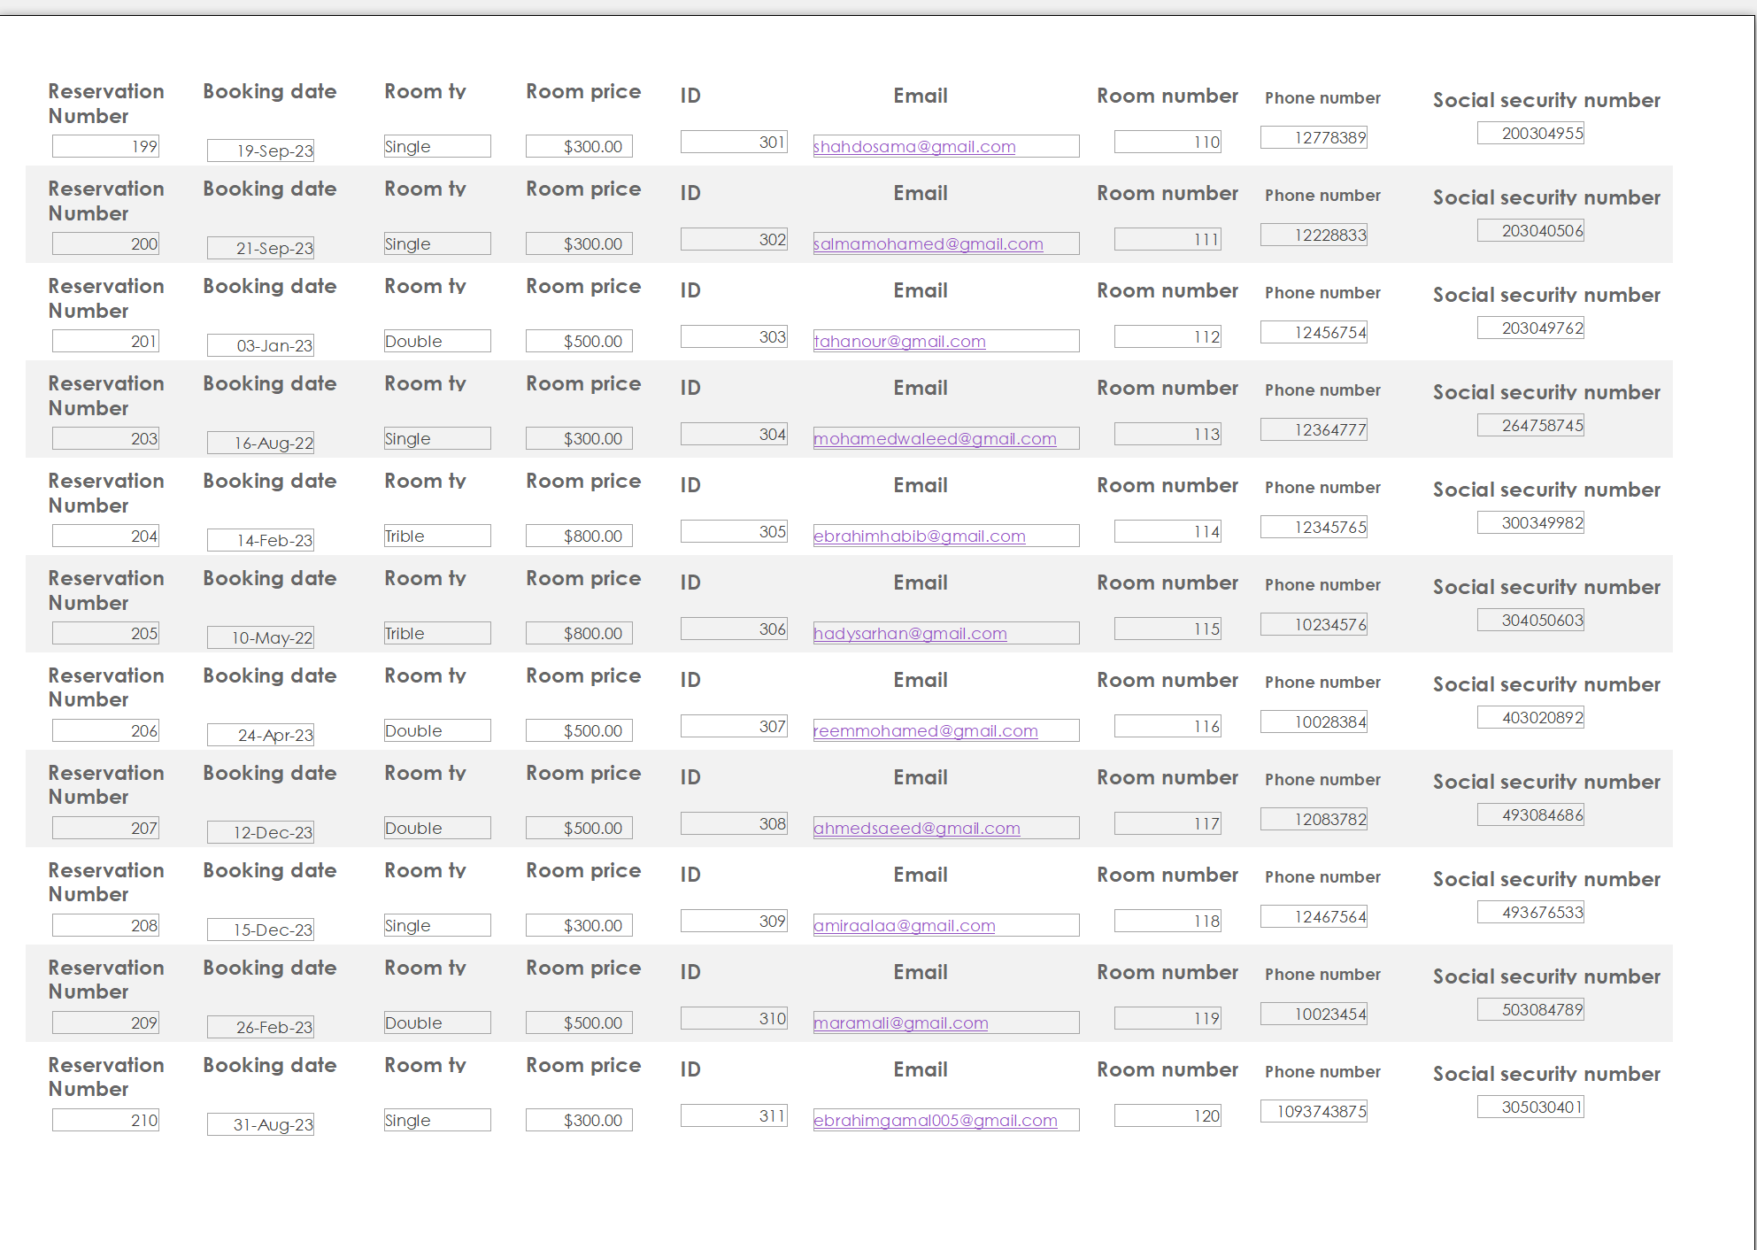

Description of Output:
This report is to show all data about all reservations.

Report 9:
Building Report:
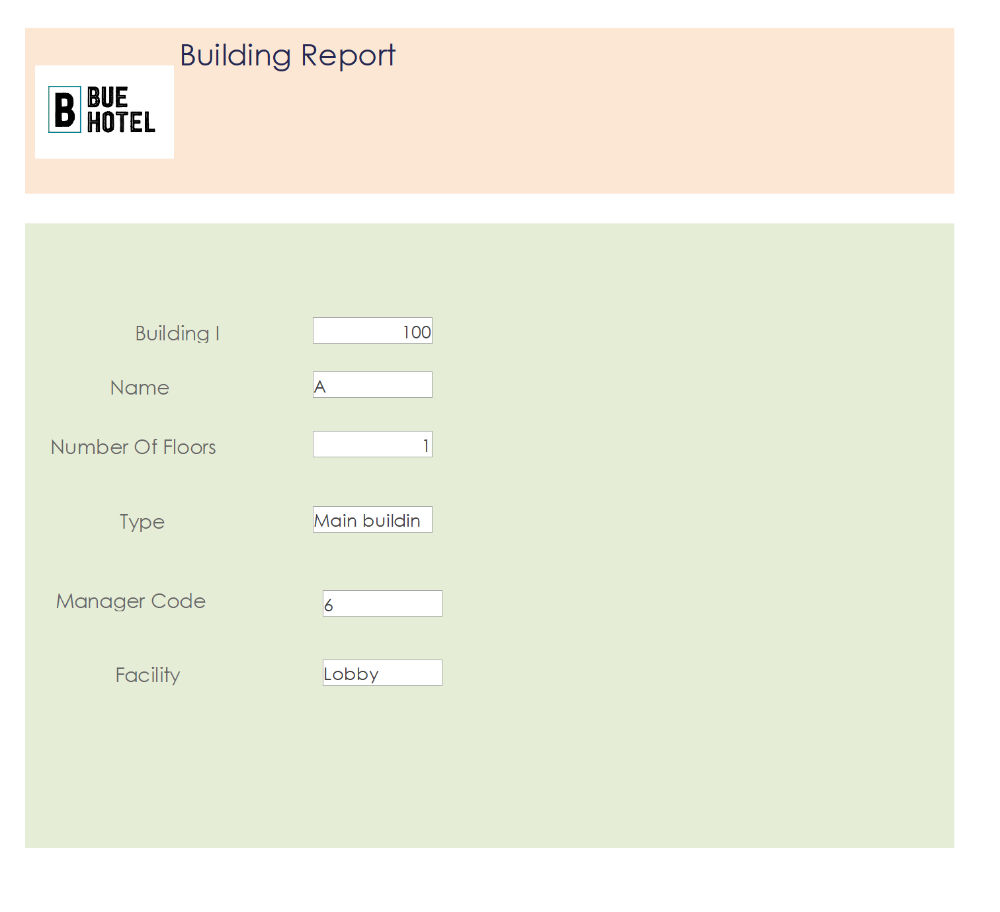

Description of Output:
The building report shows a report of every building and status only.

Report 10:
Available Room Report:
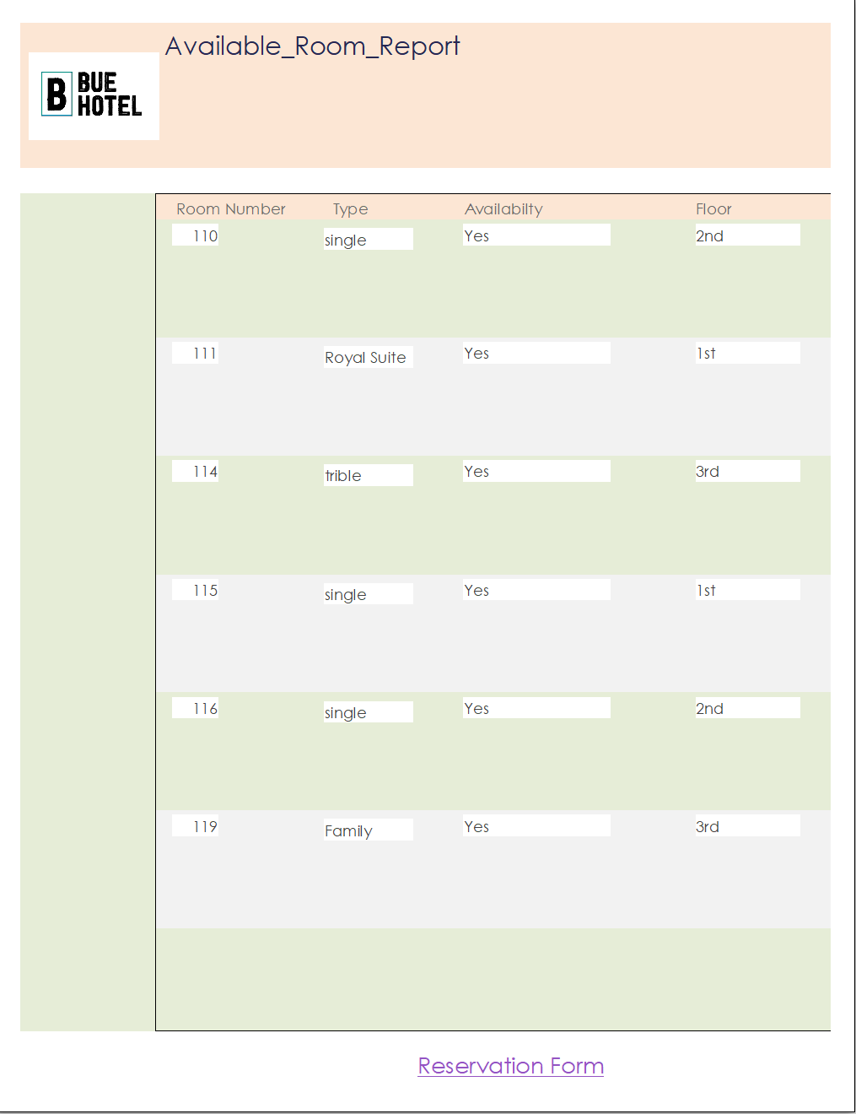

Description of Output:
The available room report helps allow the guest to check the empty rooms and to do the reserving form and reserve a room.

Report 11:
Facility Report:
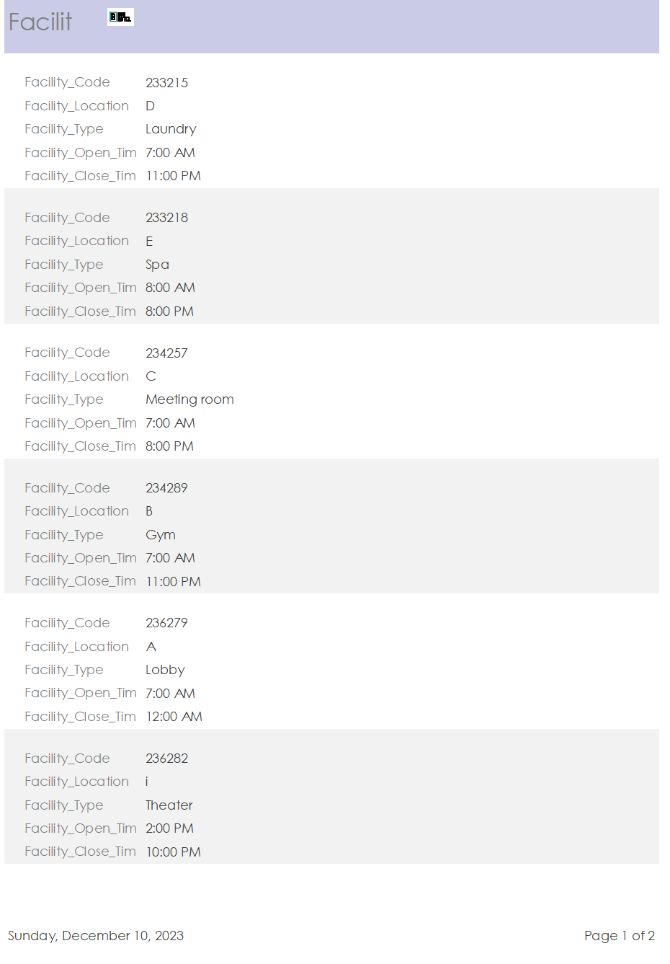

Description of Output:

Report 12:
Available_Halls Report:
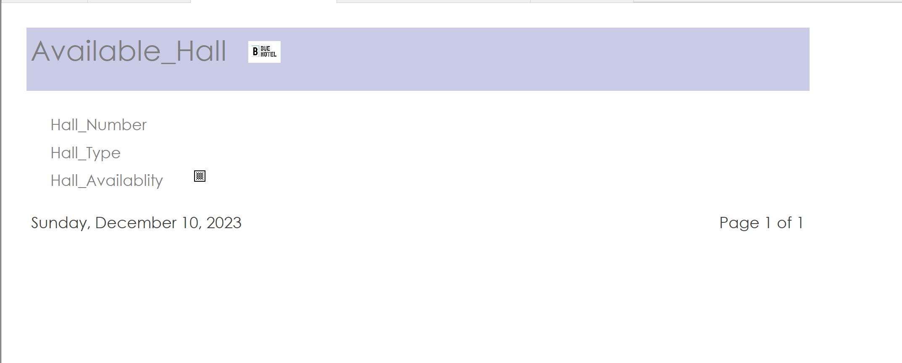

Description of Output:

Query 1:
Event_Date_Information:

Description of Output:
Retrieve all events between 12/1/2023 to 12/30/2023 by order and write their type and their hall number.

Query 2:
Manager_Data:

Description of Output:
Retrieve all information about each manager as their name, address, building code, and job description.

Query 3:
Number_Of_Each_Building:

Description of Output:
Retrieve the number of each building type.

Query 4:
Ascendingly ordered bill amount:

Description of Output:
Retrieve the bill amount of each guest, identified by his SSN, in ascending order along with the payment method.

Query 5:
Guests in 2021:

Description of Output:
Retrieve the guests who visited the hotel in 2021.

Query 6:
Guests with more than $3000 bill amount:

Description of Output:
This query retrieves the guests, identified by SSN, who have paid more than $3000.

Query 7:
Maintenance_Start_Date_Between_3/1/2024_And_10/1/2024:

Description of Output:
Retrieve Maintenance_Start_Date between 3/1/2024 and 10/1/2024.

Query 8:
Similar_Salary:

Description of Output:
Retrieve how many housekeepers have the same salary (only if they are more than 1 housekeeper).

Query 9:
HowManyFemaleAndMaleInEachCity:

Description of Output:
Retrieve in housekeeper how many females and males in each city.

Query 10:
Average_And_Maximum_And_Minimum_Price_Of_Room:

Description of Output:
Retrieve the average, maximum, and minimum prices of the rooms per night.

Query 11:
Empty_Rooms:

Description of Output:
Get every available room.

Query 12:
Number_Of_Room_Per_Price:

Description of Output:
Show the number of rooms with similar prices.

Query 13:
receptionists’ salaries:

Description of Output:
This query is to retrieve the receptionist ID
, first name, last name , and salary
The salary is ordered descendingly

Query 14:
receptionists’ salary info:

Description of Output:
This query is to retrieve the average, minimum, and maximum salary earned by receptionists.

Query 15:
single rooms reservations info:

Description of Output:
This query is to retrieve data about all single rooms reserved.

Query 16:
double rooms reservations:

Description of Output:
This query is to retrieve data about all double rooms reserved.

Query 17:
trible rooms reservations:

Description of Output:
This query is to retrieve data about all trible rooms reserved.

